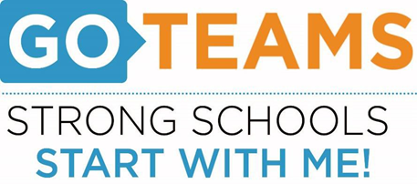

**MEETING NOTICE**

|  |  |  |  |
| --- | --- | --- | --- |
| **School** | **Date** | **Time** | **Location** |
| John Wesley Dobbs | October 24, 2024 | 3:45pm-5:45pm | [**https://atlantapublicschools-us.zoom.us/j/86844117045?pwd=bWxoZ0FQNktIVndtWXY2Mm4yVEtTdz09**](https://atlantapublicschools-us.zoom.us/j/86844117045?pwd=bWxoZ0FQNktIVndtWXY2Mm4yVEtTdz09)    **Meeting ID: 868 4411 7045**  **Passcode: GoTeam**  **Youtube: Tommy Tyson @tommytyson5756** |

**Notice Prepared By:** Jessenia Antunez **Date Posted: 10/14/24 .**

**Meeting Agenda**

(*agenda may be amended*)

*This meeting will allow for Public Comment*

1. **Call to Order**
2. **Roll Call; Establish a Quorum**
3. **Action Items**
   1. Approval of Agenda
   2. Approval of Previous Minutes
4. **Discussion Items**
   1. **Discussion Item 1**: School Strategic Plan
      1. Strategic Plan & Priorities Review
      2. SMART Goals
   2. **Discussion Item 2**: Data Discussion
      1. Spring MAP Scores
      2. GMAS
   3. **Discussion Item 3**: School Uniforms
5. **Information Items**
   1. **Principal’s Report**
      1. **Current enrollment & Leveling**
6. **Announcements**
   1. Red Ribbon Week: 10/23/24 – 10/31/24
   2. Fall Festival: 10/24/24 @3:30pm – 6:00pm
   3. Family Engagement Month: November
   4. Food Pantry: 11/6/24 @ 11:00am – 1:00pm
   5. Curriculum Night/STEAM Showcase: 11/12/24
   6. Family Engagement Luncheon: 11/13/24 @ 12:00pm
   7. Schoolwide Spelling Bee: 11/20/24
7. **Public Comments**
8. **Adjournment**